Name | Ali Hassan Soliman
Student ID | 36145211
Studio Session | 09

Part A: URL of the Visualisation
Paste your visualisation URL in the empty space below.
Tip: Test your URL in incognito mode to ensure it is a working URL

https://ahas0067.github.io/fit2179-dv-2/

Part B: Domain Description
Describe your domain chosen for DV II
My domain is basketball participation in Australia. The visualisation explores how strong basketball is as a sport by looking at national participation, state and territory differences, demographics, organisation type, and facility access in Victoria. Rather than only showing total participant numbers, the visualisation compares participation rates, player base size, age/gender patterns, and where basketball facilities are located.

Describe the Why and Who aspects of your DV II
The purpose of this visualisation is to help users understand where basketball is strongest, who participates most, and whether facility access supports participation. The intended audience is general Australian readers, students, basketball organisations, local councils, and people interested in sport participation patterns. The main tasks are to compare basketball with other sports, identify geographic differences, compare adult and child participation, examine gender and age group gaps, and understand how organised pathways and facilities shape access to the sport.

Describe the “What” aspect of your DV II
The main data comes from AusPlay basketball participation results, including estimated participants, participation rates, gender, age groups, adult/child groups, and organisation type. I also used state population data to derive participation rates by state and territory. For facilities, I used the Victorian Sport and Recreational Facilities List to identify basketball facilities, court estimates, indoor/outdoor type, and locations. Map boundary data was used for the Australia and Victoria maps, with Mapshaper used to convert to TopoJSON files. These datasets are relevant because they connect participation strength with demographic, geographic, organisational, and facility based evidence.

Describe the “How” aspect of your DV II
I used different idioms depending on the comparison task. A ranked bar chart shows where basketball sits against other sports because it is effective for ordered comparisons. A choropleth map shows state participation rates geographically, while an interactive bubble scatter compares participation rate against total player base. Bar, diverging bar, lollipop, donut, and connected dot plot idioms were used to compare age, gender, adult/child participation, organisation type, and organised versus non-organised play. Facility access is shown with a ranked LGA chart and an interactive dot map of Victorian basketball facilities.

The visualisation also includes custom summary cards to make the final findings easier to understand. These use icon based designs for participation rate, total player base, gender balance, and facility access, followed by a key takeaways section. Interactivity lets users switch the map between all, adult, and child participation rates, highlight individual states in the scatter plot, and filter the facilities map by indoor, outdoor, mixed, or all facilities. These features help users understand the data better instead of only reading fixed charts.

Part C: Sketch
A URL to a PDF document with an image of your sketch on your GitHub account.
Tip: Test your URL in incognito mode to ensure it is a working URL

https://github.com/ahas0067/fit2179-dv-2/blob/bf87e8b7772ff9304b551e88df37ecd9ff0de54b/FIT2179%20DV2%20Sketch.pdf

Paste a screenshot of your sketch for your DV II.
Note: Use the entire page here for the screenshot and ensure that it is clearly legible and visible

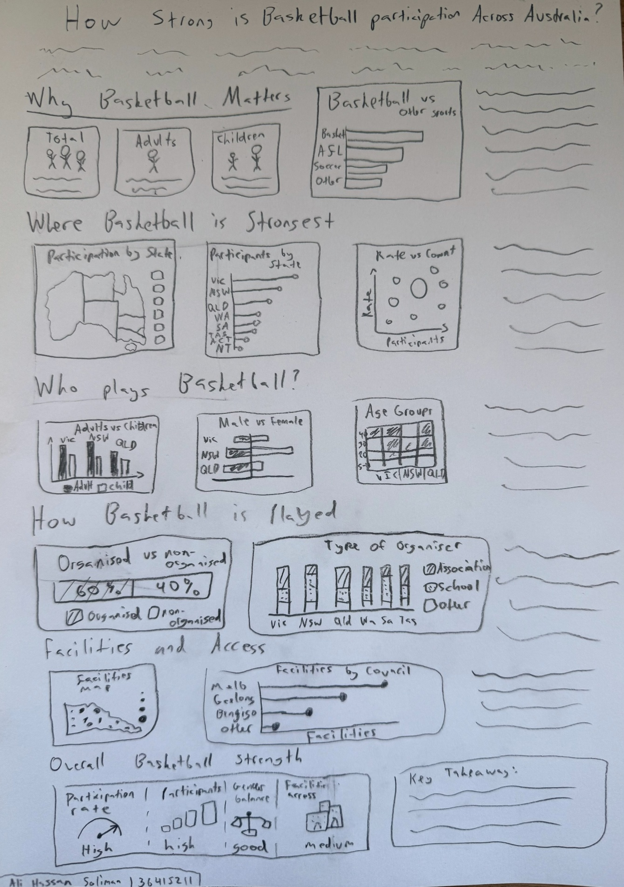

Part D: Full-size screenshot of your DV II
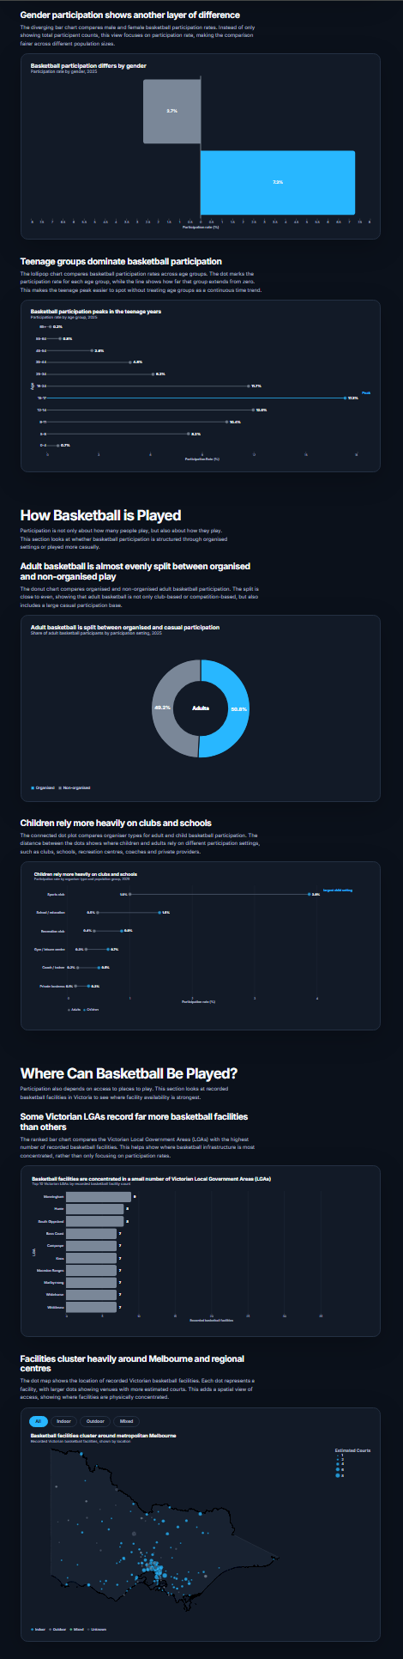
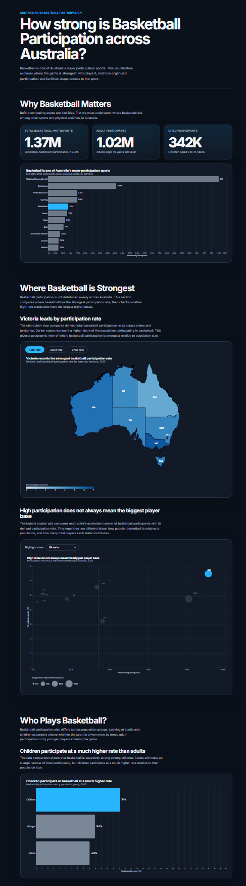
Paste a full-size screenshot of your DV II assignment from the URL here
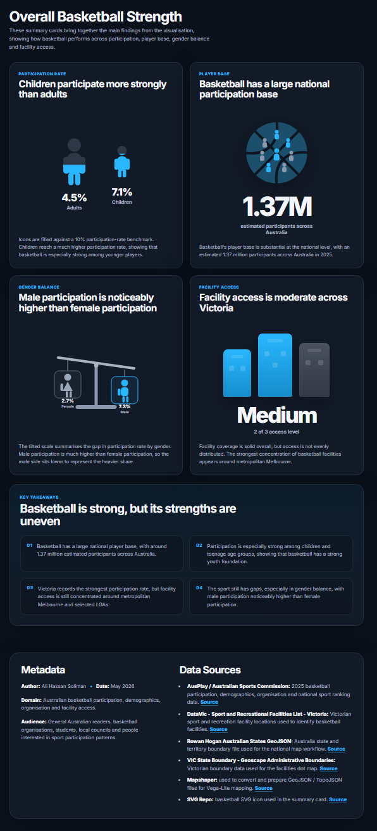

Part E: AI ACKNOWLEDGMENT
I used the AI tool ChatGPT, as a collaborative support tool during the production of this assessment. I used AI to help organise and clean large raw datasets into smaller cleaned datasets that could be used more effectively in my Vega-Lite charts. This included help with identifying useful columns, restructuring data for chart use, checking whether derived fields made sense, and preparing cleaned CSV files for participation, demographics, organisation type, state summaries, and facilities.

I also used AI to help write and refine parts of the HTML, CSS, Vega-Lite JSON, and JavaScript used in the final visualisation. For the HTML and CSS, AI helped me keep a consistent visual style across the webpage, including section layouts, chart containers, responsive spacing, summary cards, metadata, and key takeaway sections. For the Vega-Lite chart specifications, AI was used to help structure some chart JSON files, fix errors, and ensure the chosen idioms displayed the data clearly. I also used AI to help with the `vega_lite_vis.js` file so charts could resize properly across different screen sizes and remain visible without being cut off.

AI was also used to support the implementation of interactive features. These included allowing users to switch the state map between total, adult, and child participation rates, highlight individual states in the scatter plot, and filter the Victorian facilities dot map by facility type such as indoor, outdoor, mixed, or all.

For the final custom summary cards, I developed the overall idea myself, including the concepts for participation rate, player base, gender balance, and facility access. I then used AI to help implement the icon-based visuals for these cards, such as the filled adult/child icons, basketball/player-base icon, gender balance scale, and facility access buildings. I reviewed and adjusted these outputs so they matched the visual style and message of the final site.

The AI output was not used without review. I tested the code myself in the browser, checked console errors, compared the results against my datasets, and made changes when the output did not work or did not match my design goals. Many parts of the project required multiple iterations, where I accepted, rejected, edited, or rebuilt AI suggestions based on what appeared in the final webpage. I also made my own design decisions about the structure, ordering, chart idioms, colour scheme, annotations, interactivity, summary cards, and final written explanations.

Overall, AI was used as a coding, debugging, writing, and data preparation assistant, but the final design direction, interpretation of the data, chart selection, testing, editing, and final implementation decisions were completed by me.

